**Node Js Architecture**

Node.js is an open-source, cross-platform JavaScript runtime environment built on Chrome's V8 JavaScript engine. It allows developers to run JavaScript code outside a web browser, enabling server-side scripting to create dynamic web pages and build scalable network applications. Node.js uses an event-driven, non-blocking I/O model, making it lightweight, efficient, and suitable for real-time applications with high concurrency.

Node.js has revolutionized server-side development by allowing developers to use JavaScript, a language traditionally associated with client-side scripting, for both the front and back end, enabling seamless communication between the two. Its versatility, robustness, and thriving community support have made Node.js a go-to choice for building modern, scalable web applications.

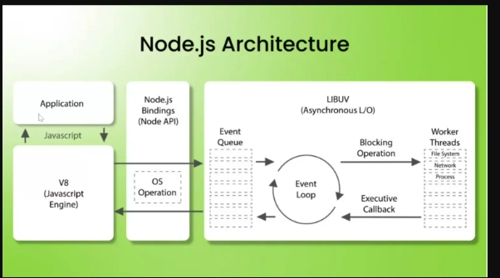

This diagram illustrates the high-level architecture of a Node.js application. Let me break down the key components:

1. Application: This represents the actual application or program built using Node.js, which is powered by the V8 (JavaScript engine) at its core.

2. Node.js Bindings (Node API): This layer provides the API that allows the application to interact with the underlying operating system (OS) and access system-level resources and functionality.

3. OS Operation: This represents the operating system on which the Node.js application is running, providing access to low-level system operations.

4. LIBUV (Asynchronous I/O): LIBUV is a cross-platform library that provides an event-driven I/O model and a thread pool for offloading CPU-intensive tasks. It is responsible for the asynchronous and non-blocking nature of Node.js.

5. Event Queue: This is a queue that holds incoming events, which are then processed by the Event Loop.

6. Event Loop: The Event Loop is the core of Node.js. It continuously checks the Event Queue and executes the appropriate callback functions when events occur.

7. Worker Threads: Worker Threads allow Node.js to leverage multiple CPU cores for CPU-bound tasks, providing a way to achieve parallelism and improved performance.

8. Blocking Operations: This includes operations that can block the Event Loop, such as file system, network, and other I/O-bound tasks. These are typically handled by the Worker Threads to maintain the responsiveness of the Event Loop.

9. Executive Callback: When a blocking operation completes, the Executive Callback is responsible for notifying the Event Loop and triggering the corresponding callback function.

This architecture allows Node.js to efficiently handle I/O-bound tasks asynchronously, while offloading CPU-intensive tasks to Worker Threads, enabling Node.js to be scalable and performant for a wide range of applications.

Advantages of moving to Nodejs

Here are some of the key advantages of moving to Node.js:

1. Scalabilit: Node.js is designed to be highly scalable, allowing developers to build applications that can handle a large number of concurrent connections without performance degradation. This is achieved through its non-blocking, event-driven architecture.

2. Efficiency: Node.js is built on the V8 JavaScript engine, which provides fast execution of JavaScript code. The event-driven model and asynchronous I/O operations in Node.js make it efficient for building real-time, data-intensive applications.

3. Full-stack JavaScript: Node.js allows developers to use JavaScript on both the client-side (in the browser) and the server-side, enabling a "full-stack JavaScript" approach. This can improve developer productivity, as they can use the same language and share code between the client and server.

4. Rapid Development:Node.js comes with a vast ecosystem of open-source libraries and frameworks, such as Express.js, which accelerate the development process by providing ready-made solutions for common web application requirements.

5. Microservices Architecture: Node.js is well-suited for building microservices-based architectures, which can improve scalability, flexibility, and maintainability of applications.

6. Real-time Applications: Node.js excels at building real-time applications like chat servers, web-based games, and IoT (Internet of Things) solutions, thanks to its event-driven and non-blocking nature.

7. Lightweight and Fast: Node.js is designed to be lightweight and fast, making it a good choice for building high-performance, low-latency applications.

8. Cross-Platform Compatibility: Node.js is a cross-platform runtime, allowing developers to build applications that can run on various operating systems, including Windows, macOS, and Linux.

9. Large and Active Community: Node.js has a large and active community of developers who contribute to its growth, create third-party modules, and provide support through forums, tutorials, and other resources.

10. Improved Productivity: The use of JavaScript, a language familiar to many web developers, and the availability of a rich ecosystem of tools and libraries can improve developer productivity when working with Node.js.

These advantages make Node.js a popular choice for building a wide range of web applications, APIs, microservices, and real-time solutions.